WEST LONDON WASTE AUTHORITY
Report of the Managing Director | 6 December 2022
WLWA Business Plan

SUMMARY
This report provides an update of the Authority’s Business Plan for 2022/23. The key points are:
- The first review of the WLWA business plan 2022/23 demonstrates one red risk: The proportion of residents using the food waste recycling service has not increased for 15 months. This prevents WLWA from demonstrating reduced cost in the 2023 budget.
- If Boroughs can find ways to ensure all residents use the food waste recycling services, the WLWA budget could reduce by c£2m per annum and recycling rates would increase.
- WLWA has identified potential savings of between £6m and £13m linked to service changes and reduced waste to be realised by Boroughs. Needing greater collaboration, these savings will be investigated further through the Environment Directors Board.
- WLWA and Boroughs are waiting for multiple government responses to consultations and draft Regulations to follow the Environment Act 2021. These are all crucial information to inform our route map to deliver the JMWMS.
- The risks identified in the Business Plan have prompted a full review of the WLWA strategic risk register. This will be reported to the Audit Committee in January 2023.
RECOMMENDATION(S)
The Authority is asked to:-
- Request Boroughs communicate to residents the urgency and importance of using the food waste recycling systems.
- Note the updated risk register which will be reported to the Audit Committee in January.
- Request Environment Directors and Finance Directors include the potential WLWA savings for consideration during Borough budget setting processes.

- Background – During several years of fast moving change the West London Waste Authority business plan has focused on outcomes. The organisation has developed and cemented its values of Leadership, Empowerment, Agility and Partnership to support these outcomes. Lattice software was introduced in July 2022 which allows all employees’ strategic objectives to be self-input, linked to the organisations strategic goals, visible to all employees and self-reported. The Managing Director’s three strategic objectives to which all employees’ objectives are linked are: Resilience and preparation, Projects and Investments and Communicating the Vision.
- The Business Plan activities are detailed in appendix 1. The Food Waste Programme has been identified as a red risk. WLWA has made its investments and the KPIs were established but the recent waste composition analysis indicates that the proportion of residents using the food waste recycling service has not increased. This is preventing WLWA from demonstrating reduced cost in the budget for 2023. If Boroughs can find ways to ensure all residents use the food waste recycling services, the WLWA PaYT charges could reduce by c£2m per annum, recycling rates would increase, there would be better use of existing infrastructure and less waste for disposal. WLWA will continue to work with the Environment Directors Board to increase the uptake of food waste recycling. More detail is provided in the Food Waste project update and in sections 3, 4 and 5 below.
- Environment Directors Priorities for the next two years were re-established in September 2022 following a WLA workshop attended by all WLWA Boroughs. Four key priority areas were established and there was common ground on the key priorities and the supporting information and ideas generated. The four priorities for the next two years are shown below, supported by examples:

- Joint Municipal Waste Management Strategy – The framework of a joint plan for 2030 to be developed by WLWA and Boroughs was agreed in March 2022. The joint plan must incorporate managing the rising cost of inflation which can only be countered in WLWA by reducing the amount of waste collected. It is vital in this year that we
- Increase the proportion of residents using the food waste service and
- Prevent waste at source in the recycling centres.
The agreed framework is shown below:
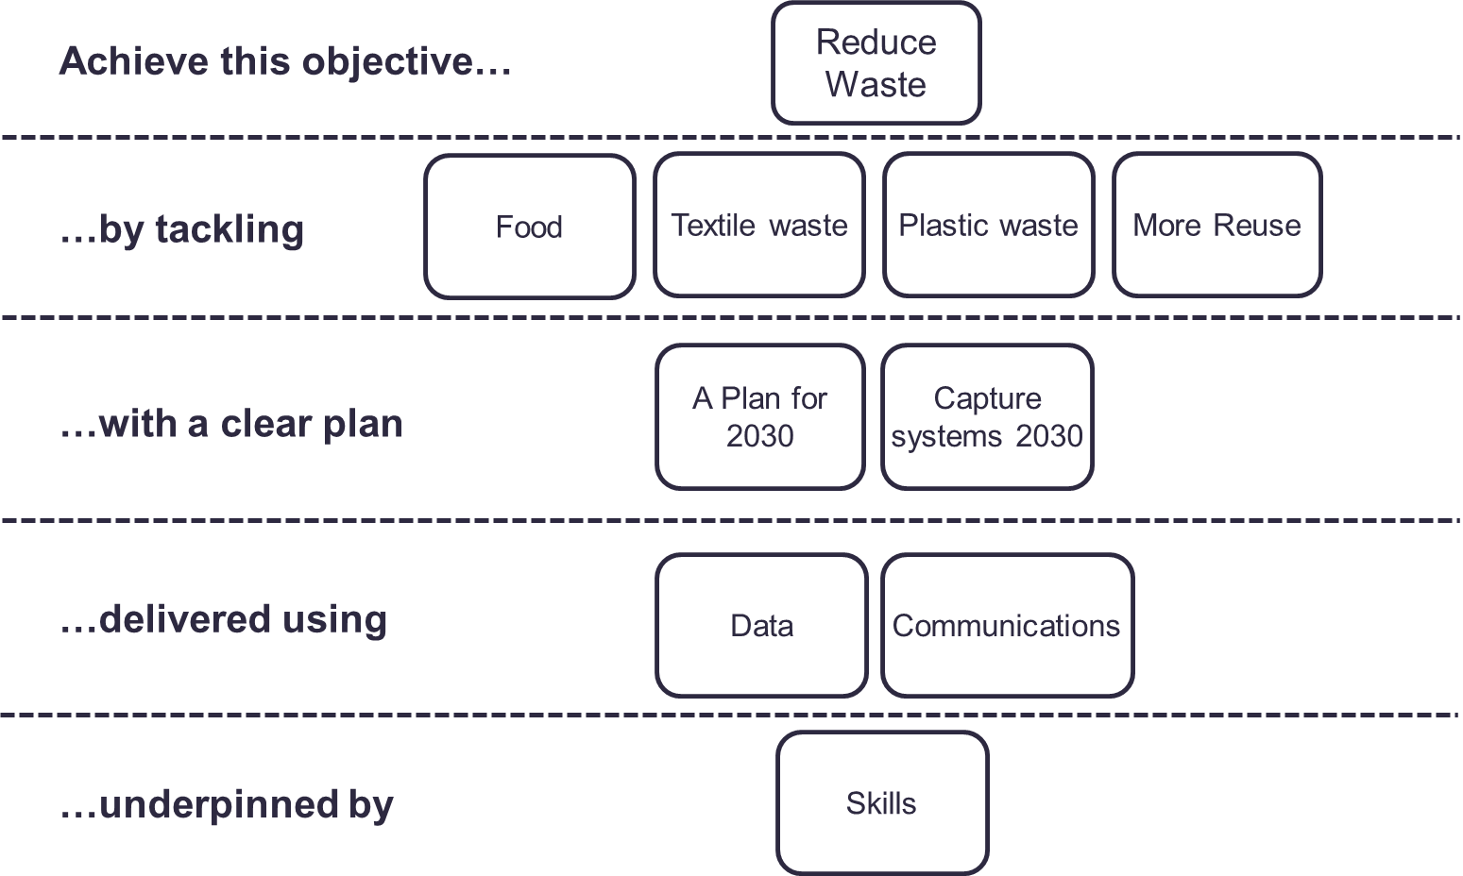
- Risks - The inflationary pressure and budget deficits Boroughs are facing are substantial and will require transformational change if not addressed through new funding. The WLWA business plan focuses on reducing the carbon impact of services and reducing the cost of services. WLWA has identified potential savings of between £6m and £13m linked to service changes and reduced waste. Needing greater collaboration, these savings will be investigated further through the Environment Directors Board. In addition:
- The Emissions Trading Scheme has the potential to increase costs by around £36 per tonne, a significant cost increase of £14.5m pa or c.£2.5m pa to each Borough. To mitigate this cost WLWA must reduce the proportion of fossil waste in waste. The WLWA finance strategy supports investment in waste reduction and Borough recycling services.
- Multiple changes are being considered to our waste system concurrently but responses to consultation and direction is not being published promptly e.g. packaging extended producer responsibility, consistency, deposit return schemes, digital waste tracking, reform to carriers, brokers and dealers regulations, including energy from waste facilities in the BEIS Emissions Trading Scheme (ETS) and more.
- The use of statutory guidance to interfere at a tactical level e.g. removing charges for “diy” construction waste at recycling centres (HRRCs) deemed to be household waste, and preventing the use of booking systems will have unintended consequences and make it harder to achieve nationally set targets. The unintended consequences include increased cost to taxpayers and more CO2eq spent on waste management activities.
- The Environment Agency (EA) approach to separation of soft domestic seating containing persistent organic pollutants (POPs) places increased expense directly onto Local Authorities. The EA indicates more guidance will follow relating to more materials.
- Financial Implications – The implications of most residents not using the food waste recycling services is c.£2m per annum additional unnecessary spend on residual waste. If Boroughs can reduce food waste now, we can use that saving to remove more fossil waste from waste and mitigate the future cost of our inclusion in the emissions trading scheme (ETS). The future cost risk is calculated by tonnes of waste and proportion of fossil waste in the waste. ETS could cost WLWA c£14.5m per annum and is effectively a tax on waste produced by residents. This business plan supports our financial principles of reducing costs, providing stability around WLWA levies, effective management of financial risk and where appropriate, creating infrastructure and collaborative projects with Boroughs.
- Risk Management – The biggest risk is the financial cost of not driving change. Individual projects carry risks and these will be considered on a project by project basis.
- Health and Safety Implications – Food waste recycling is an existing service, there are no new H&S implications.
- Legal Implications – The Environment Bill 2021 makes it law that all households must receive a food waste recycling service. The date for compliance has not yet been set but is expected to be c.2025. In the WLWA area some flats and flats above shops do not yet have this service. The problem we are finding however, is that even when offered, most residents are not using the food waste recycling service. The outstanding consultations indicate a need for us to create incentives for more reuse, more recycling and less waste and this supports our financial principles of reducing waste to reduce costs and provide stability around WLWA levies.
- Impact on Carbon reduction – Increasing food waste recycling reduces food waste because people realise how much they are throwing away. The carbon reduction impact is felt throughout the supply chain including production, transport and waste. Food waste reduction also saves money in residents’ pockets.
- Impact on Environment Directors Priorities – Ensuring all residents use the food waste recycling services addresses the key priorities of Bringing residents with us, Sustainable decision making, Decarbonisation and Dealing with financial challenges whilst delivering on climate change.
- Impact on Joint Municipal Waste Management Strategy – Ensuring all residents use the food waste recycling services address the framework of our plan for 2030 by reducing waste, by tackling food waste, delivered using data and communications.
- Impact on statutory, national and London targets - Ensuring all residents use the food waste recycling services addresses the target 65% recycling by 2035 (2030 in London). It reduces our carbon footprint, greenhouse gas emissions vehicle emissions.

Background Papers
 | Emma Beal | Managing Director | 07766 147 978
 |  | emmabeal@westlondonwaste.gov.uk

Appendix 1 Business Plan 2022/23
  - Resilience and preparation
WLWA must be prepared for significant change resulting from legislation and social and economic needs. We must remain aligned with our supply chain and Boroughs as all organisations in the resources and waste sector manage significant change.
Item | Responsible Owner | Progress to date | Outcome
Training / development opportunities for core skills are prioritised. | Managing Director | Insights training for half employees carried out and ongoing.  Coaching training for half employees carried out and ongoing.  Lean Six Sigma white belt for most employees carried out.  Data driven decision making training carried out for Managing Director and Finance Director. Power BI training carried out for MI Team. | Skills plan updated and delivered.
Chair West London Climate Emergency Officers Group | Managing Director | Updated plan post Build and Recover  Industry webinars carried out.  Presentation opportunities secured with Future Places conference. | Presentations to WL CE Board and Leaders Board, webinars and conferences.
A Joint Plan for 2030 | Head of Service Delivery | Draft legislative risk assessment created.  3 year waste programme included in budget for 2023 to support reduction of waste and increased recycling. | Risk Assessment  Timetable  Legislative matrix  5 year MTFS
Develop an HR Strategy | Finance Director | Initial scoping considered with leadership and completion planned for Q4 | HR Strategy
Prioritising Lean Six Sigma and Data driven decision making for HRRC projects | Head of Service Delivery | Lean Six Sigma and Data Driven Decision Making skills/culture roll-out plans developed.  Dashboard developed for monitoring HRRC improvements | Training outcomes
Attend and present at West London Treasurer meetings | Finance Director | Regular Finance Updates and strategic information shared at quarterly meetings | 5 year MTFS  WLT support for the Joint Plan for 2030
Build partnerships through collaborative procurements | Procurements and Contracts Manager | Procurements delivered for waste transport, green waste management and rubble management, all with a strong carbon and social value focus, and leading to savings. | Economies of scale, circular economy, low carbon and social value outcomes
Theme lead for pan-London Reducing Consumption Emissions programme | Project Manager  (E Hall) | Theme lead activities ongoing | Develop complimentary WLWA e-waste and textiles strategies

  - Projects and Investments
WLWA has invested £3m in food waste projects and £1.2m in HRRC recycling and reuse projects. We must demonstrate the waste reduction and recycling outcomes and build trust in future investment programmes.
Item | Responsible Owner | Progress to date | Outcome
WLWA Finance Strategy. | Finance Director | Finance Strategy agreed with West London Treasurers and draft presented to WLWA Members in June 2022 | Agreed Finance Strategy
Optimise income from the PPP contract | Finance Director | Work and negotiations ongoing to scrutinise income sources on the contract. | Investment in WLWA and Borough projects
Infrastructure Investment Plan | Finance Director | To be commenced Q3 | Draft Infrastructure investment plan
Food Waste Programme | Projects Director | Investments made, KPIs established.  Waste composition booked for Sept 2022. | Reduced food waste and / or increased recycling
HRRCs waste diversion programme | Operations Manager | Detailed plans improvement plans developed for two Boroughs. Plans under development for other Boroughs. | Reduced waste and / or increased recycling
Prepare for Consistency, EPR and DRS impacts on Boroughs | Senior Project Manager | Mapping software purchased  Modelling complete in one Borough | Digital twin of collection system
Create a joint Extended Producer Responsibility Strategy with Boroughs | Projects Director | To be established through Environment Directors and West London Treasurers Boards | Agreed Joint EPR Strategy

  - Communicating the Vision
WLWA must ensure the link between waste and climate is understood, build partnerships, articulate what success looks like and discuss the steps and challenges with Boroughs and supply chains along the way.
Item | Responsible Owner | Progress to date | Outcome
Circular Economy Hub at Abbey Road | Projects Director | Operational with multiple materials offtakers and fixing factory workshops.  Social value analysis underway. | CE Hub to communicate the vision in Brent
Borough Circular Economy Hub | Projects Director | Business Case and design stage for Ealing  Inclusion in project team for Harrow and Hounslow.  Scoping opportunities in remaining Boroughs | CE Hub to communicate the vision in Borough(s)
Create a virtual circular economy hub | Net Zero Carbon Manager | New website launched in June.  The Electric Repair Directory is incorporated on the website listing +100 local businesses. | Website delivered  Online virtual CE Hub
Lead WLWA Strategy Away Days | Head of Service Delivery | First strategy away day delivered on 25 March. | Progress on the joint Plan for 2030  First draft / outline of a new JMWMS
Procure a communications project to measure baseline and improve levels of understanding in West London of the link between climate emergency, waste and resources. | Net Zero Carbon Manager | Draft options appraisal for discussion  Soft market testing underway | Communications Agency Programme

